Exercise 1: Ranking and Window Functions
Goal: Use ROW_NUMBER(), RANK(), DENSE_RANK(), OVER(), and PARTITION BY. Scenario: Find the top 3 most expensive products in each category using different ranking functions.
Steps: 1. Use ROW_NUMBER() to assign a unique rank within each category.
SELECT *
FROM (SELECT
ProductID,
ProductName,
Category,
Price,
ROW_NUMBER() OVER (PARTITION BY Category ORDER BY Price DESC) AS RowNum
FROM Products
) AS Ranked
WHERE RowNum <= 3;
OUTPUT:
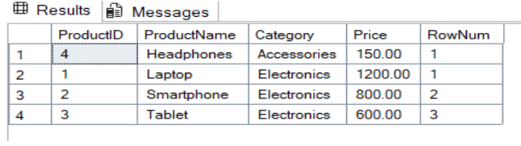
2. Use RANK() and DENSE_RANK() to compare how ties are handled.
SELECT *
FROM (
SELECT
ProductID,
ProductName,
Category,
Price,
RANK() OVER (PARTITION BY Category ORDER BY Price DESC) AS RankNum
FROM Products
) AS Ranked
WHERE RankNum <= 3;
OUTPUT:
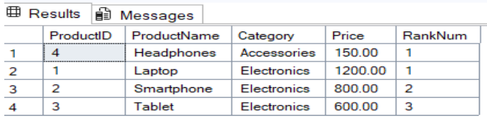
3. Use PARTITION BY Category and ORDER BY Price DESC.
SELECT *
FROM (
SELECT
ProductID,
ProductName,
Category,
Price,
DENSE_RANK() OVER (PARTITION BY Category ORDER BY Price DESC) AS DenseRankNum
FROM Products
) AS Ranked
WHERE DenseRankNum <= 3;
OUTPUT:
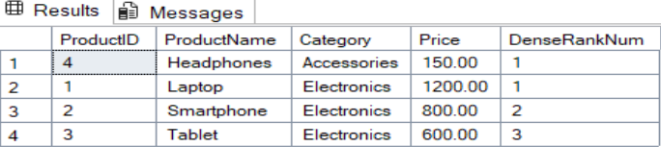
Exercise -2 Create a Stored Procedure
DROP PROCEDURE IF EXISTS sp_GetEmployeesByDepartment;
GO
CREATE PROCEDURE sp_GetEmployeesByDepartment
@DepartmentID INT
AS
BEGIN
SELECT
E.EmployeeID,
E.FirstName,
E.LastName,
E.Salary,
E.JoinDate,
D.DepartmentName
FROM Employees E
INNER JOIN Departments D ON E.DepartmentID = D.DepartmentID
WHERE E.DepartmentID = @DepartmentID;
END;
GO
EXEC sp_GetEmployeesByDepartment @DepartmentID = 2;
-- Drop if it already exists
DROP PROCEDURE IF EXISTS sp_InsertEmployee;
GO
-- Create the procedure
CREATE PROCEDURE sp_InsertEmployee
@FirstName VARCHAR(50),
@LastName VARCHAR(50),
@DepartmentID INT,
@Salary DECIMAL(10,2),
@JoinDate DATE
AS
BEGIN
INSERT INTO Employees (FirstName, LastName, DepartmentID, Salary, JoinDate)
VALUES (@FirstName, @LastName, @DepartmentID, @Salary, @JoinDate);
END;
GO
EXEC sp_InsertEmployee
@FirstName = 'Alice',
@LastName = 'Brown',
@DepartmentID = 3,
@Salary = 6200.00,
@JoinDate = '2022-09-10';
SELECT * FROM Employees;
output :
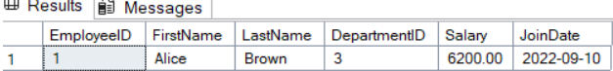
Exercise - 3 Return Data from a Stored Procedure
-- Drop if it already exists
DROP PROCEDURE IF EXISTS sp_CountEmployeesByDepartment;
GO
-- Create the procedure
CREATE PROCEDURE sp_CountEmployeesByDepartment
@DepartmentID INT
AS
BEGIN
SELECT
COUNT(*) AS TotalEmployees
FROM Employees
WHERE DepartmentID = @DepartmentID;
END;
GO
EXEC sp_CountEmployeesByDepartment @DepartmentID = 2;
OUTPUT:
